Access quick guide to logging on
As everyone should now be logging into their Access portal to see their HR and coming soon Payroll information. If you receive any error message when trying to login please contact Maurice Williams Ext. 234 for help
Here is a reminder of how-to login.
To a Device other than a mobile phone
Firstly, and most importantly please use this link to go to your login page
https://go.accessacloud.com/
This login should also be the login that appears on school desktop computer, School iPad and school laptops. Look out for the Icon 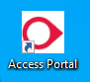 on the device you are using.
IMPORTANT: When logging in to a school device please remember DO NOT save your password details on the device and always fully sign out once you are finished. If you don’t all your personal details may become visible to the next user.
Once logged in use the access dropdown, top left, to find the People
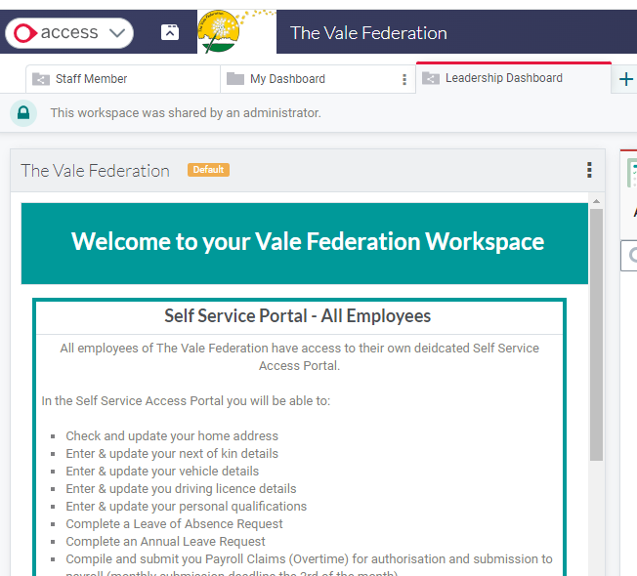
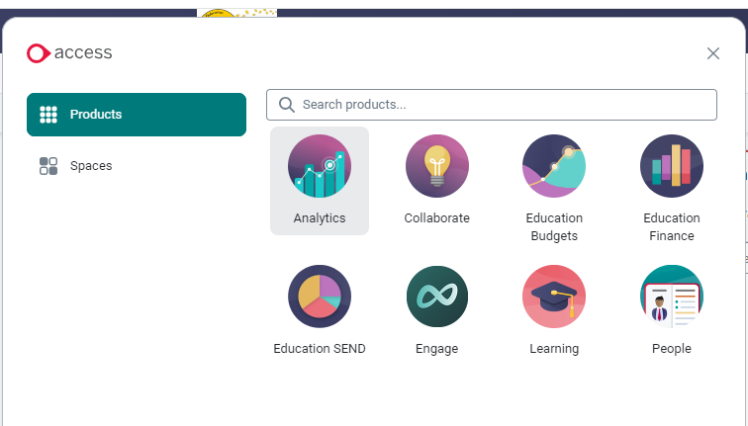
This will open the People Tab on your dashboard. From here choose Self Service to access your information.
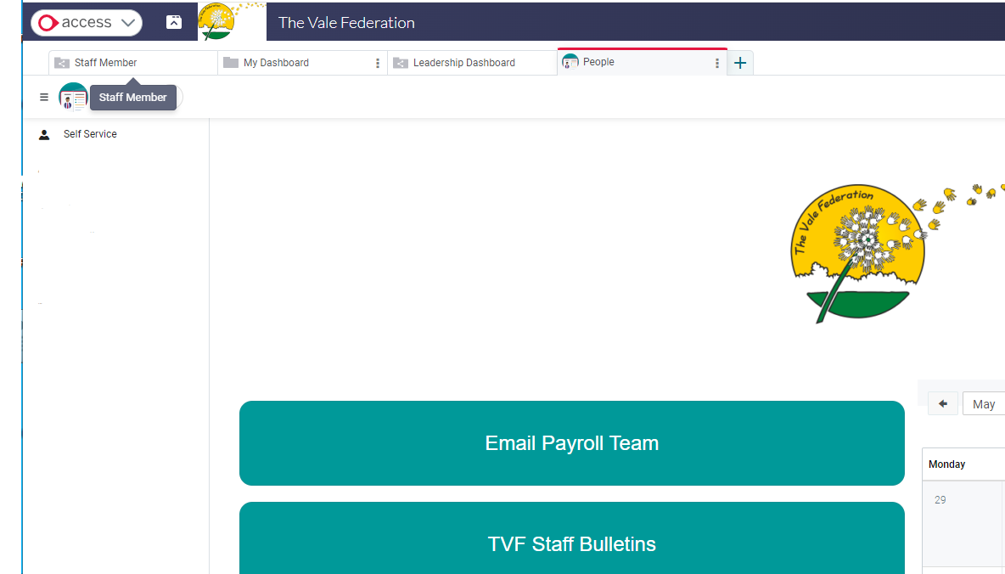
TO Access the App on a mobile Phone
Go to your phones APP store and search for Access HR and Rota. Look for the App with the Icon 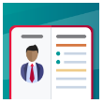. Login with the same login details. From here you will see your personal details, Leave, Absences, Payslips and important documentation.

