CPOMS Category Guide

Categories | When to use:
Attendance | To be used when adding an incident regarding a child’s attendance at school.
Behaviour | To be used when a child has had a behavioural incident in school.  Reports about behavior incidents at home should be tagged as contact.  Do not use the Concern category unless there is a safeguarding concern with the behaviour incident too.
Behaviour Intervention | When a child has needed support to regulate using strategies for example, distraction, change of face etc.
Bereavement | To be used when there has been a family death.
Child's view | If a child voices their thoughts and it needs to be recorded – negative or positive.  This can include their response from being directly involved in an incident.
Concern | To be used when there is a safeguarding concern regarding a child.  DSL’s will edit if this is a continuing or new concern  NOT to be used for a new behaviour concern, health or first aid.
Contact | To be used to document important information discussed about the child or family i.e family bereavement, change in the home circumstances, needing support, struggling emotionally.  Not to be used to document every contact. Please use your professional judgement.
Meetings | To be used when you have had a meeting face to face or on Teams.  Please chose a sub-category that suits the meeting purpose.
First aid | To be used when a child has had an accident needed first aid  (cold compress, cleaned area, plaster etc.)
Home Visit | To be used when you have gone to a child’s home.
Health | To be used when there is a health/medical update, an illness etc.
Feeding Concern | To be used when you have a concern regarding a child’s oral eating/gastrostomy/nasal feed etc.
Low Level Physical Intervention | When a child has had a Team Teach Low Level physical intervention for behaviour management, for example, a guide, stance and body positioning, release from hair pull etc.
Physical Intervention | When a child has had a Team Teach physical intervention for behaviour management, for example, holds that are restrictive to a child, small person hold, double elbow, figure of 4 etc. Also clarify in your incident the hold you used and the length of time the child was in the hold.
Well-being | When this is not a safeguarding concern, however it is an important piece of information to record. i.e Lunch not brought, inappropriate clothing for the weather, out of date food, parent-child interactions observed.  To be used if it is something that has an impact upon the child.  Depending on the frequency of occurrence, this can escalate to a safeguarding concern.  NOT to be used instead of the first aid category.

Adding an entry on CPOMS:

Student | - Start typing the child’s name and it will come up.

Incident | - Write full clear sentences – you can use bullet points.  - Write your name and put your job title the first time that you use “I”.  - No abbreviations (write the swear word/inappropriate sentences).  - Use children’s full names if you are writing an incident with others present, not initials.  - Do not include your personal opinions or assumptions.  - Be factually accurate, i.e. no personal opinions or assumptions. If you are making a professional opinion, this should be clearly recorded.

Categories | Chose the correct category, there needs to be one or more.

Maps | Complete a body map for any marks/bruising etc.

Linked Student | Only link a student if they were part of the same incident/category.  For example, the first aid was the same for 2 or more children so you can link them rather than completing another CPOMS or a behaviour incident happened, and 2 or more students were carrying out that same behaviour, you can link them.  If a child was hurt or upset by an incident, then they need a separate CPOMS entry for them.

Date/Time | Please select the date and time of the incident.

Status | Please ignore.

Assign to | Please ignore.

Files | To add documents, you need to save them to your drive first and then upload.  To save an email from parent’s/carer/professional please see Appendix A.

Alert Staff Members | Only alert staff if this is not a safeguarding concern. i.e. School Nurse, OTs, Physio, SALT.

Agency Involved | Please ignore.

Appendix A

To save an email:

Click on Print – you may need to click on the 3 dots first then print:

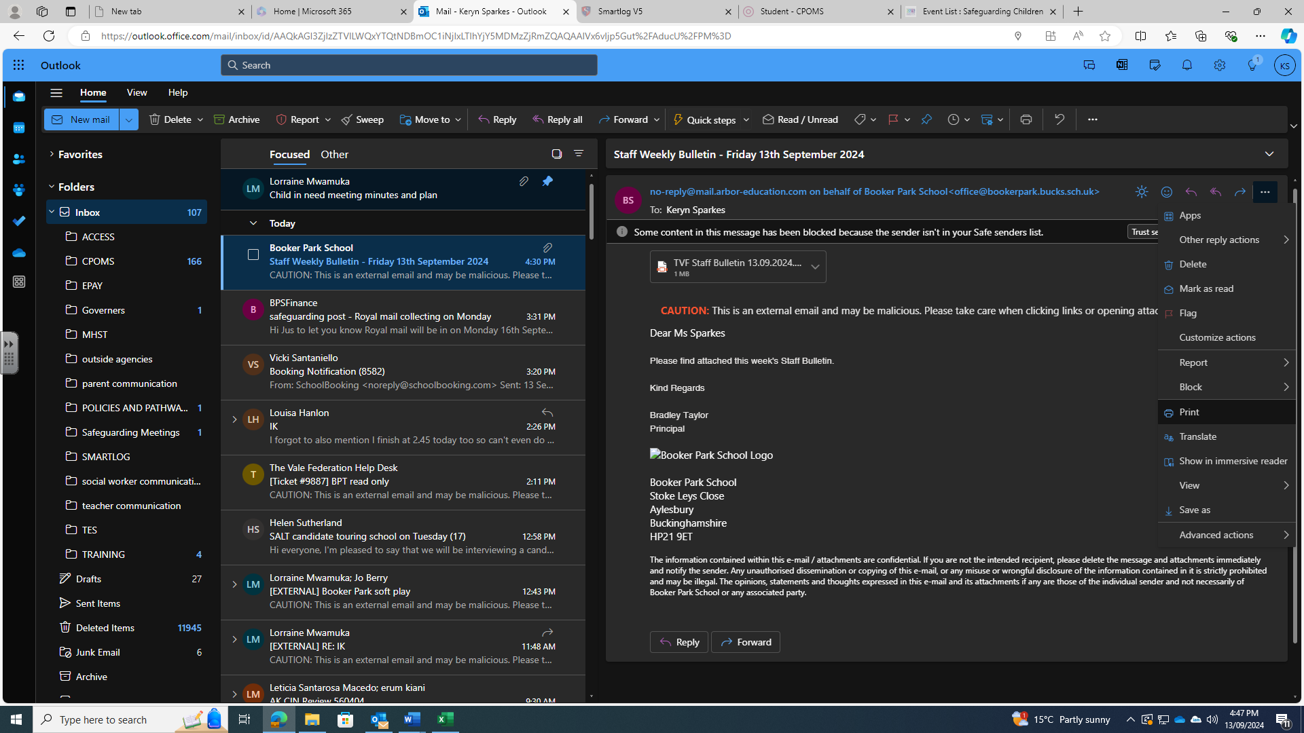

You’ll then see this screen, click on Print:
Then select Save to PDF, then click on Microsoft print to PDF and save the email to your drive.

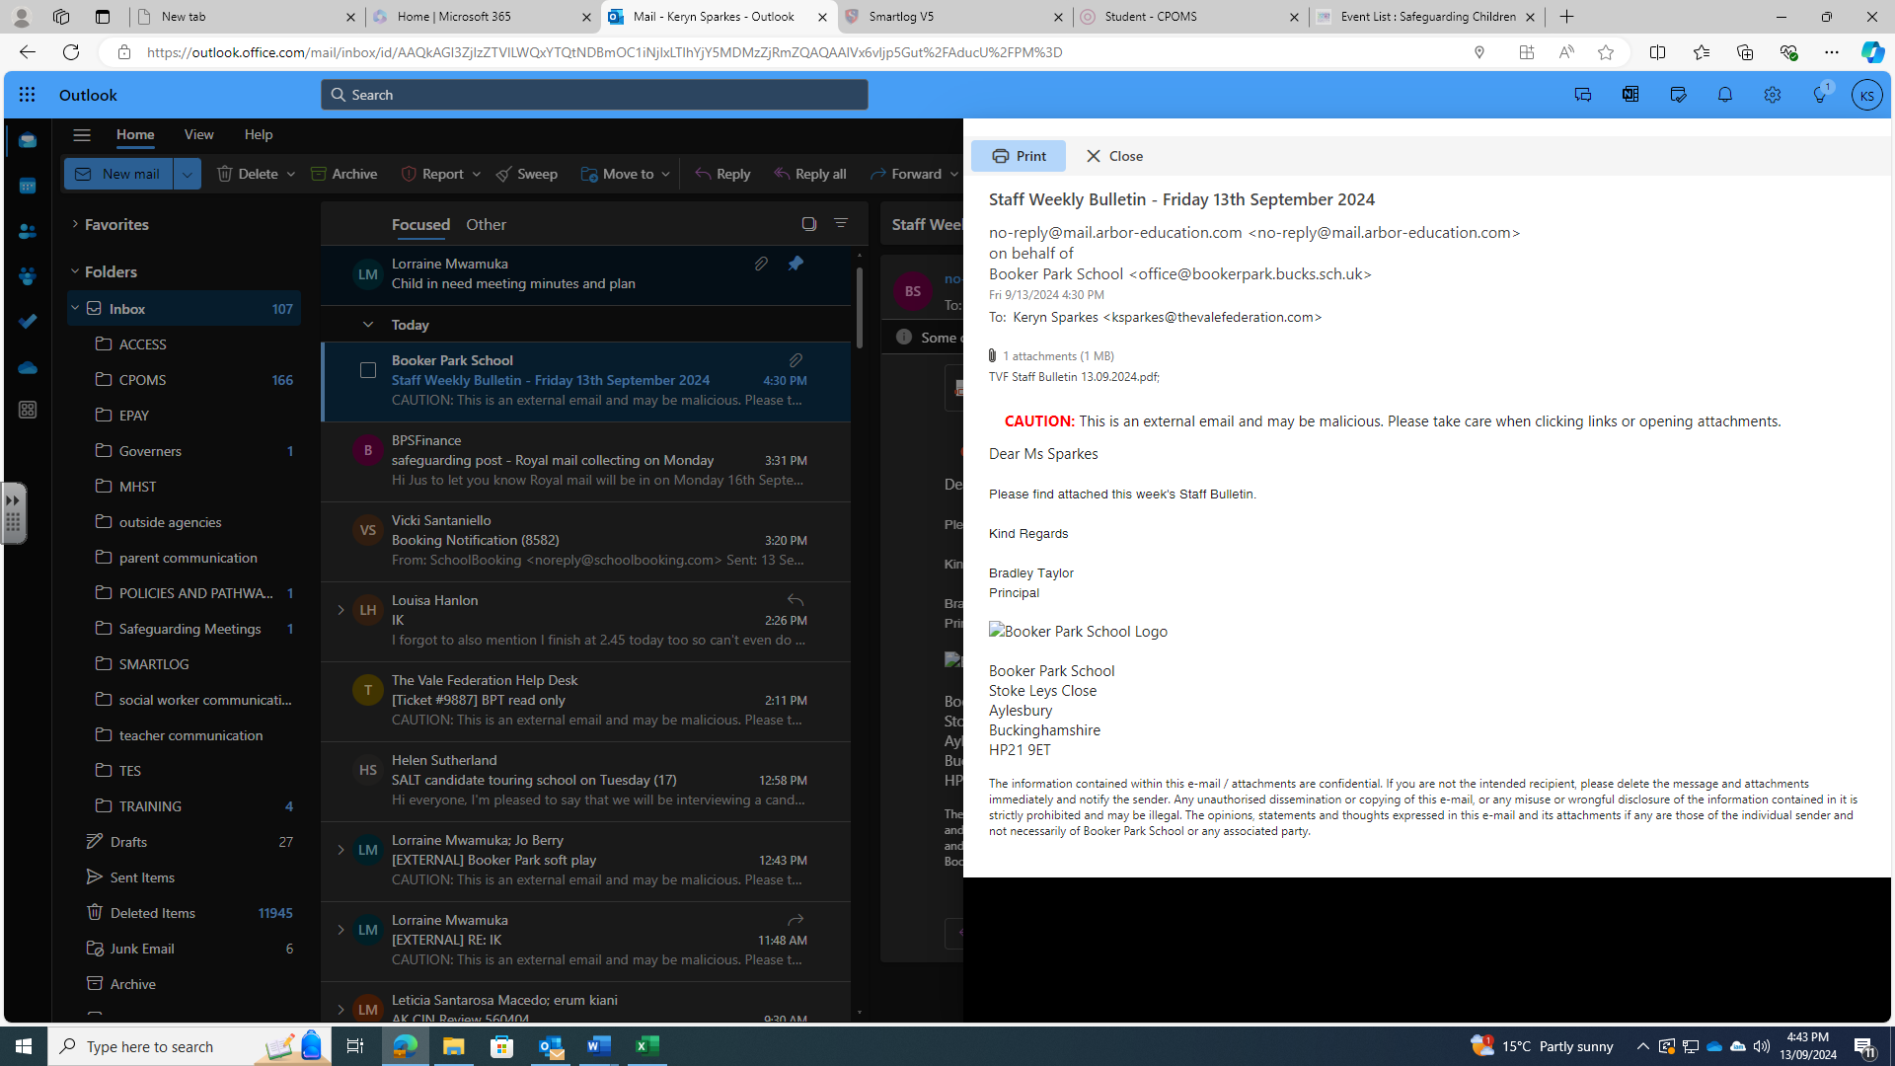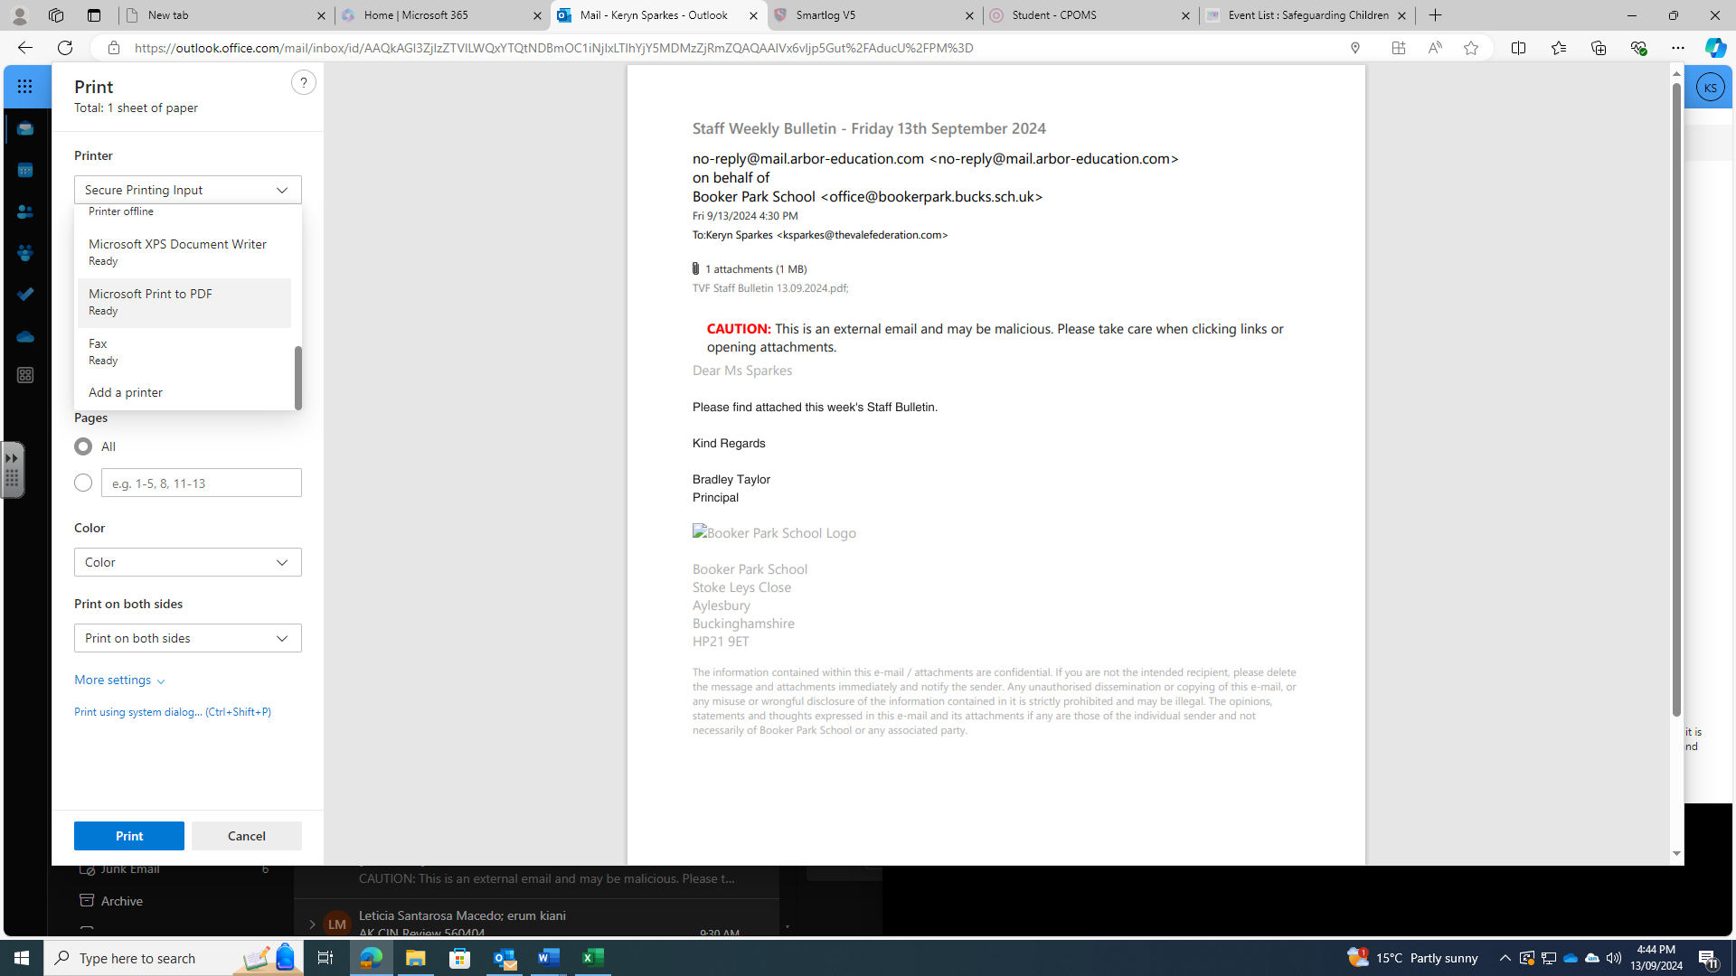

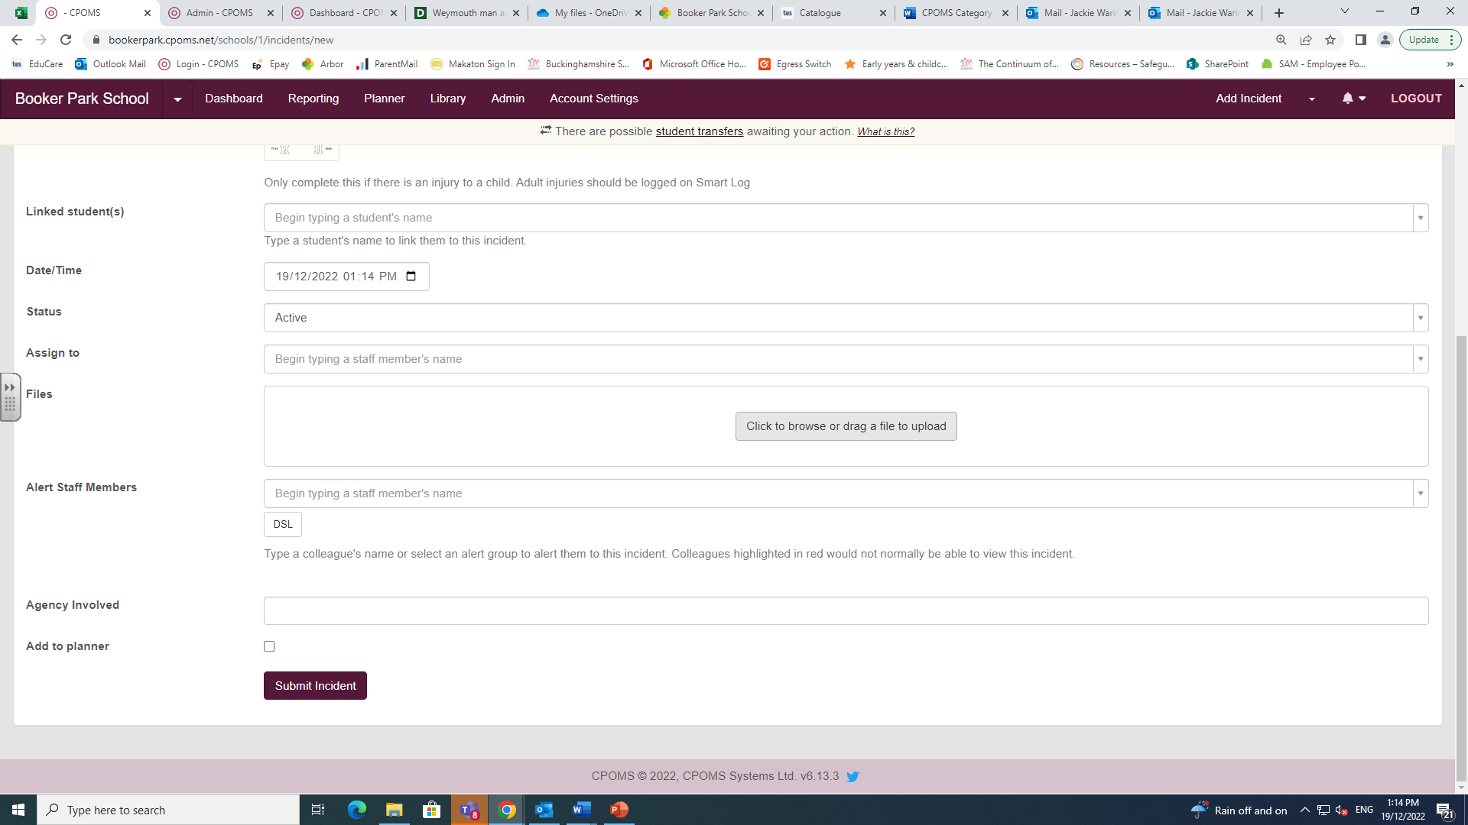
To attach a document to CPOMS, click on the highlighted section and upload your document:

